I am thinking image on left and text w/ sections on right.



Maybe this kind of feel. 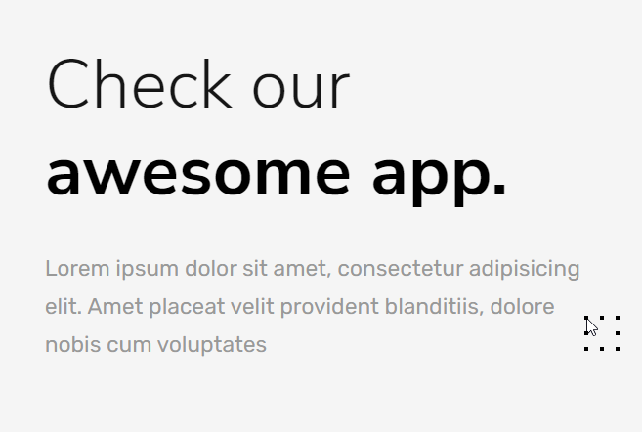

Or something else, then maybe [tags] for the technology section?

This looks good.. maybe like this?





^ maybe this but the text section is open

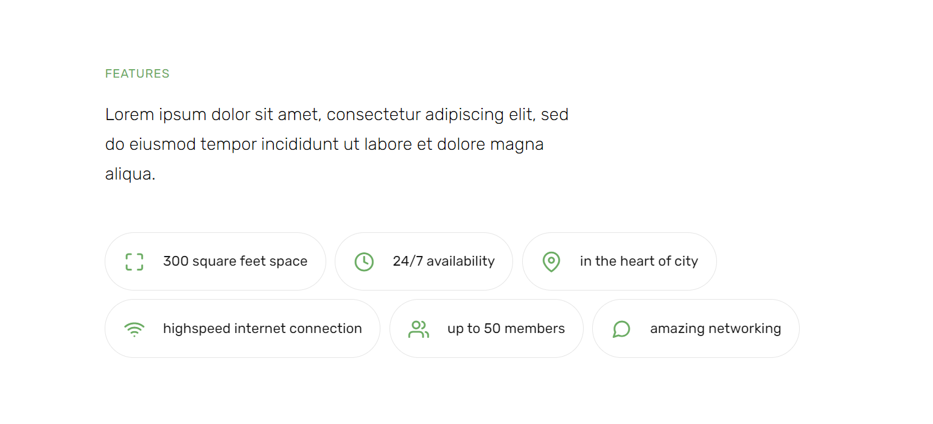

Tags: <https://mdbootstrap.com/docs/b4/jquery/javascript/tags/>

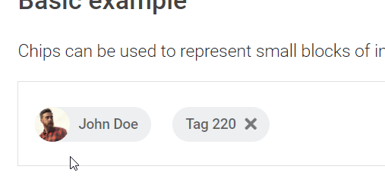

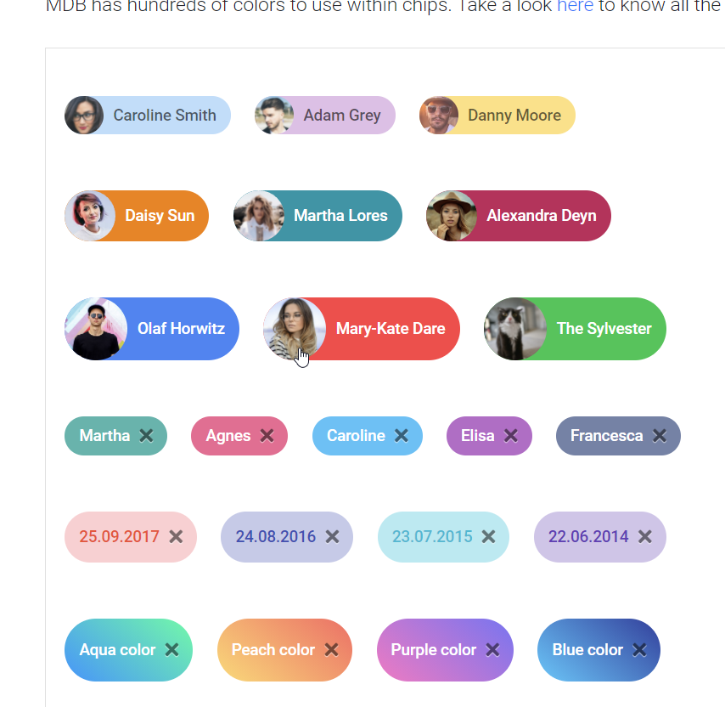

https://codepen.io/wbeeftink/pen/dIaDH

